The Summer term’s focus in Religious Education is about the role the Holy Spirit plays in our lives. This will beexplored through the themes of **Pentecost, Reconciliation and the Universal Church.**

**PENTECOST - SERVING**

(22ndApril – 17th May)

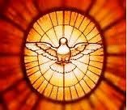

In the first topic, the children will focus on the on-going mission of Jesus in the church through the power of the Holy Spirit.

**Suggestions for me activities**

Talk about good news in your family and how you shared it.

Ask your child to tell you the story of Pentecost and the work of the Holy Spirit.

**RECONCILIATION – INTER-RELATING**

20th May – 21st June

In the next topic, we will focus on the love, compassion and forgiveness of God the Father, revealed in Jesus and poured out by the Spirit to bring forgiveness through the sacrament of Reconciliation.

**Suggestions for home activities**

Talk together about times when you have forgiven and been forgiven.

Discuss the importance of saying sorry. Look for opportunities for forgiveness and reconciliation in the day to day life of the family.

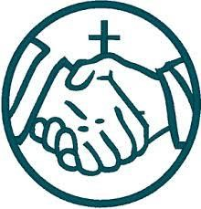

**UNIVERSAL CHURCH – WORLD**

(24th June – 19th July)



The final topic of the term focuses on the same love revealed in the diversity of the world and its people, and in the gifts of theSpirit that are demonstrated in the values of love, joy, justice and peace for all people.

**Suggestions for home activities**

Together, look through a family scrapbook or photograph album of a visit to a place that is special for your family.

Look at a globe or an atlas. Find a special place and pray for the people of that country.

Discuss how we can look after our world and support our neighbours, near and far.

**OTHER FAITH WEEK**

**SIKHISM**

Pupils studied their second Other Faith Week in Autumn Term due to term dates for Autumn and Summer Terms

**Special Feast Days and Celebrations**

**The month of May is dedicated to Our Lady**

**The ascension of the lord**

9th May

After his Resurrection, Jesus appeared to his disciples over a period of forty days. Ascension Day is when we celebrate Jesus’ return to his Father in Heaven.

**Pentecost sunday**

19th May

This is the day we celebrate the coming of the Holy Spirit and the birthday of the Church.

**The most holy trinity**

26th May

Today we celebrate our belief in the Trinity, the three persons of God: The Father, the Son and the Holy Spirit.

**The most holy body and blood of christ**

30th May

On this feast we give thanks to God for the gift of Jesus in the form of bread and wine.

**The most sacred heart of jesus**

7th June

On this day we remember how much Jesus loves us all.

**Saint Antony’s feast day**

13th June

We celebrate the lives of these important saints who helped establish the Christian Church.

***‘Come and See’***

Religious Education

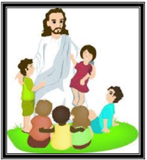

Parents’ Newsletter

Summer Term 2024

*‘Come and See at Home’*